Zepr - Zombie Engineering Project

User Manual

## 

## Contents

## 

#### Introduction ..………………………………………………………………………………...02

#### Main Menu ..…………………………………………………………………………………03

#### Stage and Character Selection ……………………………………………………………….04

#### Pause Menu ………………………………………………………………………………….05

#### Gameplay …………………………………………………………………………………….06

## 

#### Full list of characters and power ups ...………………………………………………………09

## 

## 

## 

## Introduction

#### Scenario

After a hard night of partying after the dreaded POPL exam, you wake up to find yourself in the middle of town, your friends nowhere to be found.

As you try and recall how you ended up here, you hear a low rumbling sound coming from the alleyway near you.

A horde of decaying zombies suddenly appears out from the alleyway, their clothes tattered, blood and bone sticking out of their bodies.

Not soon after, the zombies notice you and charge towards you, trampling over each other, their rumbles turning into screams and cries.

But in the spur of the movement, you suddenly realize...

You forgot to hand in your SEPR assessment!

Your goal is to survive and defeat the horde of zombies and get back to your accommodation, to hand in your SEPR assessment before the deadline is over.



## Main Menu

## 

After launching the game, you will be navigated to the main menu.

Click “Start” to begin the game.

Click “Exit” to close the game.

## 

## 

## 

## 

## Stage and Character Selection

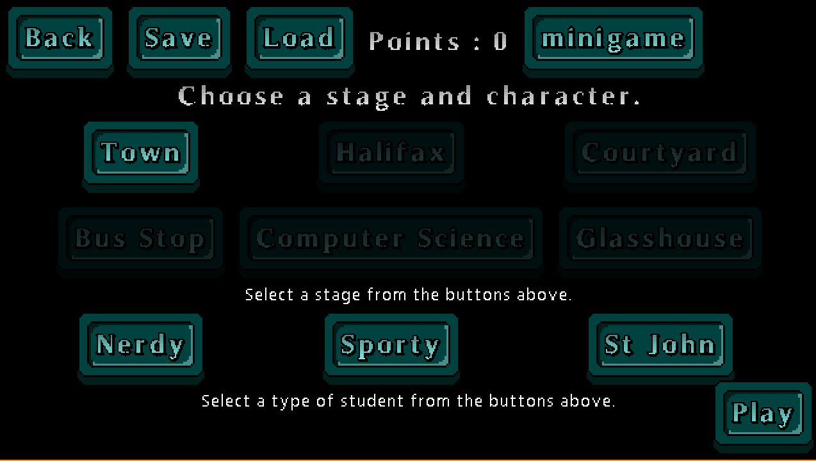

#### Stage

Stage selection allows you to select which stage you wish to play in, where each stage will offer different obstacles and hence require different strategies to overcome.

Select a stage you’ve unlocked. A locked stage is indicated by the button being greyed out. Complete the stage prior to unlock it!

#### Characters

Character selection allows you to play as a different character, where each character will offer unique strengths over the other.

Select either one of “Nerdy”, “Sporty” or “St Johns”.

#### Minigame

Go play tic-tac-toe for some bonus points

## Pause Menu

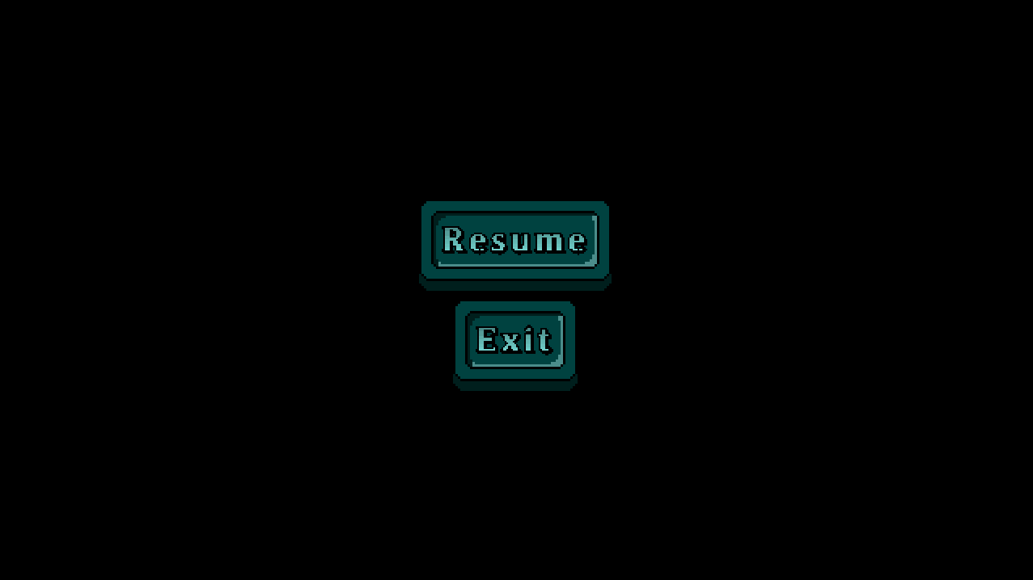

You can pause the game by pressing the “Esc” button.

To return to the game, click the “Resume” button.

To close the game, click the “Exit” button.

## 

## Gameplay

#### Controls

|  |  |
| --- | --- |
| **Key** | **Action** |
| W | Moves the character up the screen |
| A | Moves the character left on the screen |
| S | Moves the character right on the screen |
| D | Moves the character down on the screen |
| LMB (Left Mouse Button) | The character attacks. |
| Escape | Brings up the Pause Menu |

#### Graphical Interface

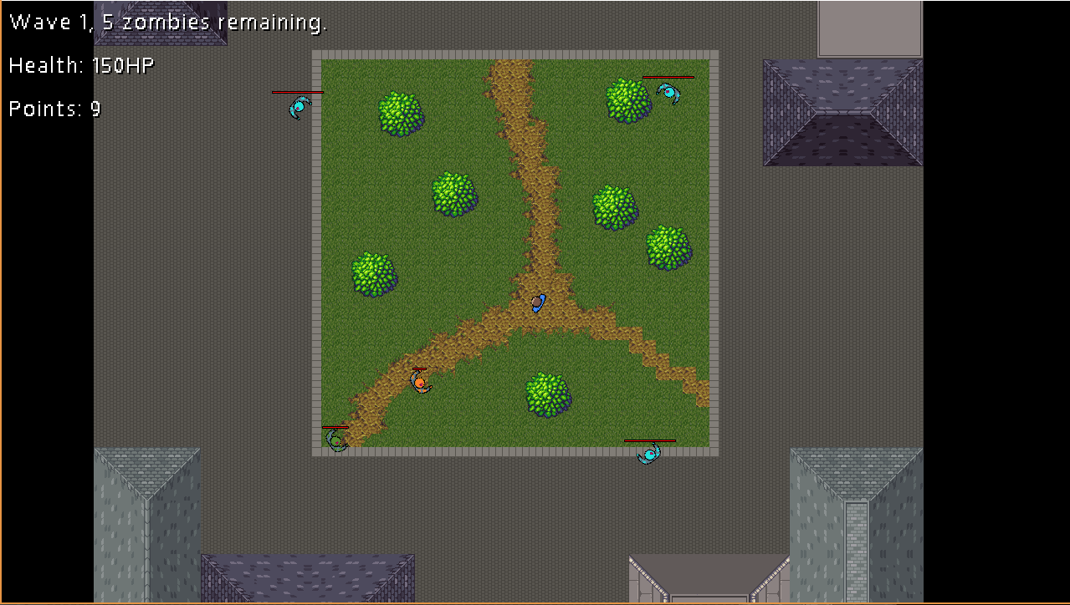

Information on the wave number, the number of zombies remaining in the wave, the player’s health total and the current number of points is shown on the top left of the screen.

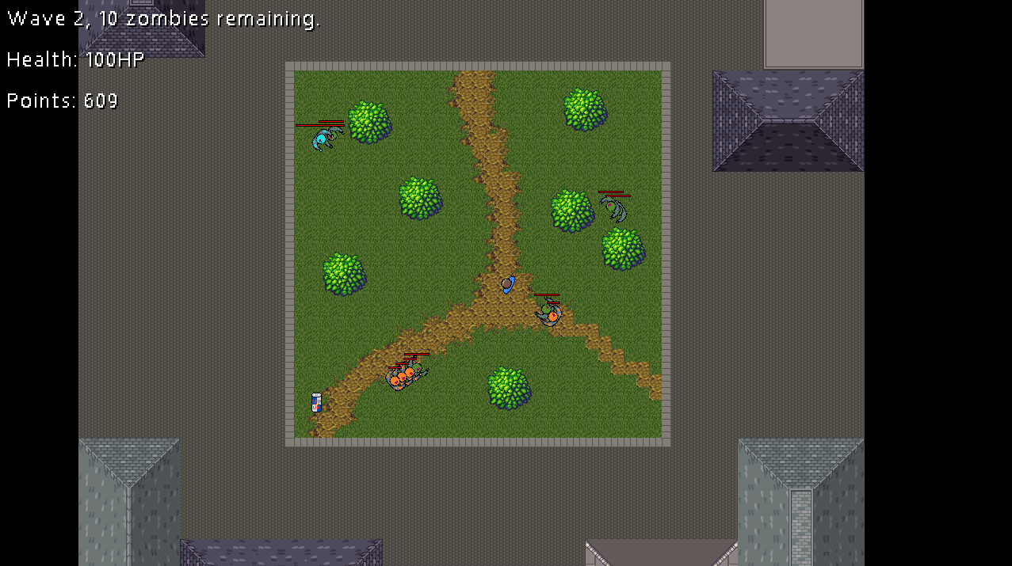

Players must defeat all of the zombies in the wave to progress to the next wave. After completing 3 waves, the stage is complete, and the next stage is unlocked (if available).

To complete the game, the player must complete all sixstages, “Town”, “Halifax”, “Courtyard”, “Bus Stop”, “Computer Science” and “Glasshouse”.

However if the player’s health drops down to 0 before completing all six stages, the player loses the game and must start again.

#### 

#### 

#### Tic-Tac-Toe

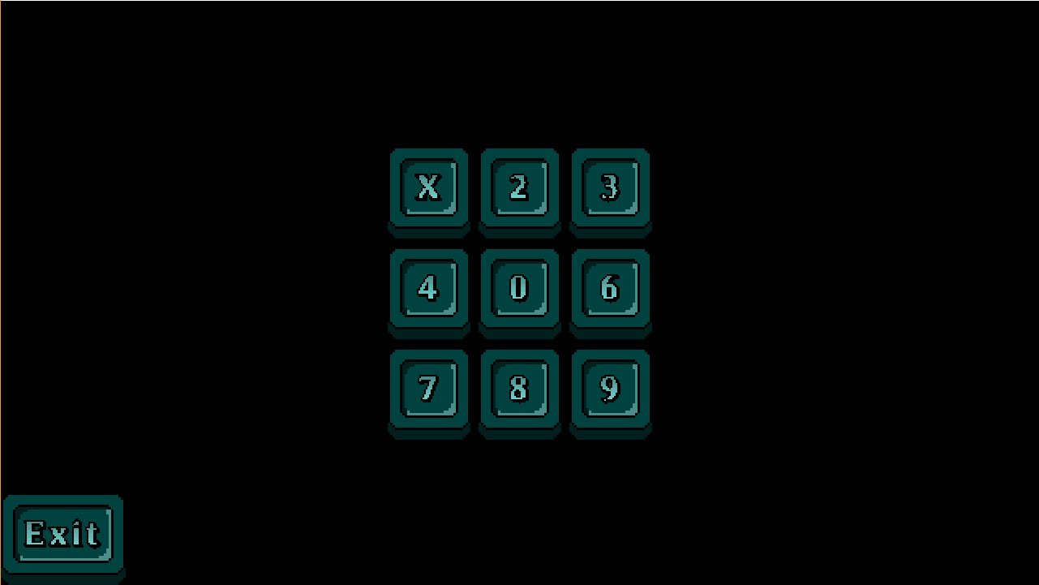

Beat the AI at tic-tac-toe for 1000 extra bonus points!

Click on any of the available spaces to change it’s value to a 0. Try to get three in a row before the AI does.

## Full list of characters and power ups:

#### 

#### Characters:

**Nerdy**



Has higher health.

**Sporty**



Has greater mobility.

**St Johns**



Hard mode.

Zombies:

**Zombie 1**



**Zombie 2**



**Zombie 3**



**Boss 1**



**Boss 2**

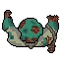

#### Power Ups:

**Heal**



Heals the player.

**Speed Up**



For the next 10 seconds, increases the movement speed of the player.

**Immunity**



For the next 5 seconds, makes the player immune to zombie attacks.

Power Downs:

**Speed Down**



For the next 10 seconds, decreases the movement speed of the player.

**Damage Up**



For the next 5 seconds, increases the amount of damage the player does by..